Types of data
Volunteer data- Data that you willingly share and store in the internet
Inferred data- Data that can be used to track your movement and location(example: credit card or atm cards)
Observed data- data that is being observed through your devices with or without your knowledge( example social medias collecting our information for providing ads)

Common Methods of Data Transmission
After the data is transformed into a series of bits, it must be converted into signals that can be sent across the network media to its destination. Media refers to the physical medium on which the signals are transmitted. Examples of media are copper wire, fiber-optic cable, and electromagnetic waves through the air. A signal consists of electrical or optical patterns that are transmitted from one connected device to another. These patterns represent the digital bits (i.e. the data) and travel across the media from source to destination as either a series of pulses of electricity, pulses of light, or radio waves. Signals may be converted many times before ultimately reaching the destination, as corresponding media changes between source and destination.
There are three common methods of signal transmission used in networks:
- Electrical signals - Transmission is achieved by representing data as electrical pulses on copper wire.
- Optical signals - Transmission is achieved by converting the electrical signals into light pulses.
- Wireless signals - Transmission is achieved by using infrared, microwave, or radio waves through the air.

Bandwidth
Bandwith refers to the speed at which the data is transferred through the media. It is the capacity to carry the data. It is usually calculated by calculating the number of bits transferred in a second.
1Kbps
1Mbps
1MBps
Bps(bits per second) is the fundamental unit of bandwidth
Throughput
Like bandwidth, throughput is the measure of the transfer of bits across the media over a given period of time. However, due to a number of factors, throughput does not usually match the specified bandwidth. Many factors influence throughput including:
- The amount of data being sent and received over the connection
- The types of data being transmitted
- The latency created by the number of network devices encountered between source and destination
Latency refers to the amount of time, including delays, for data to travel from one given point to another.
Throughput measurements do not take into account the validity or usefulness of the bits being transmitted and received. Many messages received through the network are not destined for specific user applications. An example would be network control messages that regulate traffic and correct errors.
In an internetwork or network with multiple segments, throughput cannot be faster than the slowest link of the path from sending device to the receiving device. Even if all or most of the segments have high bandwidth, it will only take one segment in the path with lower bandwidth to create a slowdown of the throughput of the entire network
Peer-to-Peer Networks
Client and server software usually run on separate computers, but it is also possible for one computer to run both client and server software at the same time. In small businesses and homes, many computers function as the servers and clients on the network. This type of network is called a peer-to-peer (P2P) network.
The simplest P2P network consists of two directly connected computers using either a wired or wireless connection. Both computers are then able to use this simple network to exchange data and services with each other, acting as either a client or a server as necessary.
Multiple PCs can also be connected to create a larger P2P network, but this requires a network device, such as a switch, to interconnect the computers.
The main disadvantage of a P2P environment is that the performance of a host can be slowed down if it is acting as both a client and a server at the same time. The figure lists some of the advantages and disadvantages of peer-to-peer networks.
In larger businesses, because of the potential for high amounts of network traffic, it is often necessary to have dedicated servers to support the number of service requests.

Network Infrastructure
The path that a message takes from its source to destination can be as simple as a single cable connecting one computer to another, or as complex as a network that literally spans the globe. This network infrastructure is the platform that supports the network. It provides the stable and reliable channel over which our communications can occur.
The network infrastructure contains three categories of hardware components, as shown in the figure:
- End devices(pc, mobile)
- Intermediate devices(switch, router)
- Network media(wiresless media, wan media, lan media)

ISP Services
An Internet Service Provider (ISP) provides the link between the home network and the internet. An ISP can be the local cable provider, a landline telephone service provider, the cellular network that provides your smartphone service, or an independent provider who leases bandwidth on the physical network infrastructure of another company.
Many ISPs also offer additional services to their contract subscribers, as shown in the figure. These services can include email accounts, network storage, and website hosting and automated backup or security services.
ISPs are critical to communications across the global internet. Each ISP connects to other ISPs to form a network of links that interconnect users all over the world. ISPs are connected in a hierarchical manner that ensures that internet traffic generally takes the shortest path from the source to the destination.
The internet backbone is like an information super highway that provides high-speed data links to connect the various service provider networks in major metropolitan areas around the world. The primary medium that connects the internet backbone is fiber-optic cable. This cable is typically installed underground to connect cities within continents. Fiber-optic cables also run under the sea to connect continents, countries, and cities.
Cable and DSL Connections
Most home network users do not connect to their service providers with fiber-optic cables. The figure illustrates common connection options for small office and home users. The two most common methods are as follows:
- Cable - Typically offered by cable television service providers, the internet data signal is carried on the same coaxial cable that delivers cable television. It provides a high bandwidth, always on, connection to the internet. A special cable modem separates the internet data signal from the other signals carried on the cable and provides an Ethernet connection to a host computer or LAN.
- DSL - Digital Subscriber Line provides a high bandwidth, always on, connection to the internet. It requires a special high-speed modem that separates the DSL signal from the telephone signal and provides an Ethernet connection to a host computer or LAN. DSL runs over a telephone line, with the line split into three channels. One channel is used for voice telephone calls. This channel allows an individual to receive phone calls without disconnecting from the internet. A second channel is a faster download channel, used to receive information from the internet. The third channel is used for sending or uploading information. This channel is usually slightly slower than the download channel. The quality and speed of the DSL connection depends mainly on the quality of the phone line and the distance from the central office of your phone company The farther you are from the central office, the slower the connection.

LAN Wireless Frequencies
The wireless technologies most frequently used in home networks are in the unlicensed 2.4 GHz and 5 GHz frequency ranges.
Bluetooth is a technology that makes use of the 2.4 GHz band. It is limited to low-speed, short-range communications, but has the advantage of communicating with many devices at the same time. This one-to-many communication has made Bluetooth technology the preferred method for connecting computer peripherals such as wireless mice, keyboards and printers. Bluetooth is a good method for transmitting audio to speakers or headphones.
Other technologies that use the 2.4 GHz and 5 GHz bands are the modern wireless LAN technologies that conform to the various IEEE 802.11 standards. Unlike Bluetooth technology, 802.11 devices transmit at a much higher power level giving them a great range and improved throughput. Certain areas of the electromagnetic spectrum can be used without a permit.

Wi-Fi Networks
A number of standards have been developed to ensure that wireless devices can communicate. They specify the RF spectrum used, data rates, how the information is transmitted, and more. The main organization responsible for the creation of wireless technical standards is the Institute of Electrical and Electronics Engineers (IEEE).
The IEEE 802.11 standard governs the WLAN environment. There are amendments to the IEEE 802.11 standard that describe characteristics for different standards of wireless communications. Wireless standards for LANs use the 2.4 GHz and 5 GHz frequency bands. Collectively these technologies are referred to as Wi-Fi.
Another organization, known as the Wi-Fi Alliance, is responsible for testing wireless LAN devices from different manufacturers. The Wi-Fi logo on a device means that this equipment meets standards and should operate with other devices that use the same standard.
Wireless standards are constantly improving the connectivity and speed of Wi-Fi networks. It is important to be aware of new standards as they are introduced because manufacturers of wireless devices will implement these standards quickly in their new products.

Network Mode
The 802.11 protocol can provide increased throughput based on the wireless network environment. If all wireless devices connect with the same 802.11 standard, maximum speeds can be obtained for that standard. If the access point is configured to accept only one 802.11 standard, devices that do not use that standard cannot connect to the access point.
A mixed mode wireless network environment can include devices that use any of the existing Wi-Fi standards. This environment provides easy access for older devices that need a wireless connection but do not support the latest standards.
When building a wireless network, it is important that the wireless components connect to the appropriate WLAN. This is done using the SSID.
The SSID is a case-sensitive, alphanumeric string that contains up to 32 characters. It is sent in the header of all frames transmitted over the WLAN. The SSID is used to tell wireless devices, called wireless stations (STAs), which WLAN they belong to and with which other devices they can communicate.
We use the SSID to identify a specific wireless network. It is essentially the name of the network. Wireless routers usually broadcast their configured SSIDs by default. The SSID broadcast allows other devices and wireless clients to automatically discover the name of the wireless network. When the SSID broadcast is disabled, you must manually enter the SSID on wireless devices.
Disabling SSID broadcasting can make it more difficult for legitimate clients to find the wireless network. However, simply turning off the SSID broadcast is not sufficient to prevent unauthorized clients from connecting to the wireless network. All wireless networks should use the strongest available encryption to restrict unauthorized access.

The Fields of the Ethernet Frame
Ethernet is technology commonly used in local area networks. Devices access the Ethernet LAN using an Ethernet Network Interface Card (NIC). Each Ethernet NIC has a unique address permanently embedded on the card known as a Media Access Control (MAC) address. The MAC address for both the source and destination are fields in an Ethernet frame.

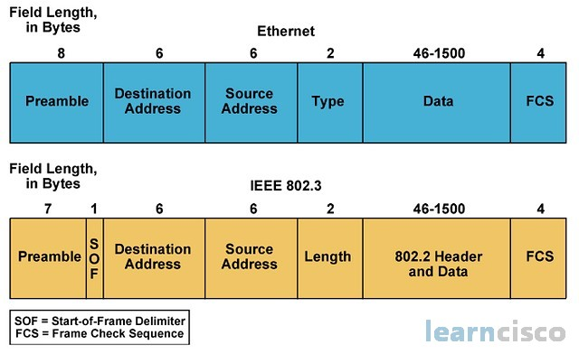

• Preamble (7 bytes)
- Pattern: 10101010 repeated.
- Purpose: Synchronize the sender and receiver clocks.
• SFD (Start Frame Delimiter, 1 byte)
- Pattern: 10101011.
- Purpose: Signals “the next bit is the start of the frame”.
• Destination MAC Address (6 bytes)
- The unique hardware address of the receiving device.
- If it’s a broadcast, it’s FF:FF:FF:FF:FF:FF.
• Source MAC Address (6 bytes)
- The hardware address of the sender.

• Type/Length (2 bytes)
- If value ≥ 1536 (0x0600), it represents EtherType (protocol).
- If value ≤ 1500, it represents payload length (IEEE 802.3 standard).
• Payload / Data (46–1500 bytes)
- Contains the Layer 3 packet (e.g., IPv4, IPv6, ARP).
- If less than 46 bytes, padding is added.
• FCS (Frame Check Sequence, 4 bytes)
- CRC-32 value for error detection.
- If the CRC doesn’t match, the frame is discarded.

The IPv4 Address
A host needs an IPv4 address to participate on the internet and almost all LANs today. The IPv4 address is a logical network address that identifies a particular host. It must be properly configured and unique within the LAN, for local communication. It must also be properly configured and unique in the world, for remote communication. This is how a host is able to communicate with other devices on the internet.
An IPv4 address is assigned to the network interface connection for a host. This connection is usually a network interface card (NIC) installed in the device. Examples of end-user devices with network interfaces include workstations, servers, network printers, and IP phones. Some servers can have more than one NIC and each of these has its own IPv4 address. Router interfaces that provide connections to an IP network will also have an IPv4 address.
Every packet sent across the internet has a source and destination IPv4 address. This information is required by networking devices to ensure the information gets to the destination and any replies are returned to the source.
Octets and Dotted-Decimal Notation
IPv4 addresses are 32 bits in length. Here is an IPv4 address in binary:
11010001101001011100100000000001
Notice how difficult this address is to read. Imagine having to configure devices with a series of 32 bits! For this reason, the 32 bits are grouped into four 8-bit bytes called octets like this:
11010001.10100101.11001000.00000001
That's better, but still difficult to read. That's why we convert each octet into its decimal value, separated by a decimal point or period. The above binary IPv4 becomes this dotted-decimal representation:
209.165.200.1

Networks and Hosts
The logical 32-bit IPv4 address is hierarchical and is made up of two parts, the network and the host. In the figure, the network portion is blue, and the host portion is red. Both parts are required in an IPv4 address. Both networks have the subnet mask 255.255.255.0. The subnet mask is used to identify the network on which the host is connected.
As an example, there is a host with an IPv4 address 192.168.5.11 with a subnet mask of 255.255.255.0. The first three octets, (192.168.5), identify the network portion of the address, and the last octet, (11) identifies the host. This is known as hierarchical addressing because the network portion indicates the network on which each unique host address is located. Routers only need to know how to reach each network, rather than needing to know the location of each individual host.
With IPv4 addressing, multiple logical networks can exist on one physical network if the network portion of the logical network host addresses is different. For example: three hosts on a single, physical local network have the same network portion of their IPv4 address (192.168.18) and three other hosts have different network portions of their IPv4 addresses (192.168.5). The hosts with the same network number in their IPv4 addresses will be able to communicate with each other, but will not be able to communicate with the other hosts without the use of routing. In this example, there is one physical network and two logical IPv4 networks.

Unicast
In the previous topic you learned about the structure of an IPv4 address; each has a network portion and a host portion. There are different ways to send a packet from a source device, and these different transmissions affect the destination IPv4 addresses.
Unicast transmission refers to one device sending a message to one other device in one-to-one communications.
A unicast packet has a destination IP address that is a unicast address which goes to a single recipient. A source IP address can only be a unicast address, because the packet can only originate from a single source. This is regardless of whether the destination IP address is a unicast, broadcast, or multicast.

Broadcast
Broadcast transmission refers to a device sending a message to all the devices on a network in one-to-all communications.
A broadcast packet has a destination IP address with all ones (1s) in the host portion, or 32 one (1) bits.
Note: IPv4 uses broadcast packets. However, there are no broadcast packets with IPv6.
A broadcast packet must be processed by all devices in the same broadcast domain. A broadcast domain identifies all hosts on the same network segment. A broadcast may be directed or limited. A directed broadcast is sent to all hosts on a specific network. For example, a host on the 172.16.4.0/24 network sends a packet to 172.16.4.255. A limited broadcast is sent to 255.255.255.255. By default, routers do not forward broadcasts.

Multicast
Multicast transmission reduces traffic by allowing a host to send a single packet to a selected set of hosts that subscribe to a multicast group.
A multicast packet is a packet with a destination IP address that is a multicast address. IPv4 has reserved the 224.0.0.0 to 239.255.255.255 addresses as a multicast range.
Hosts that receive particular multicast packets are called multicast clients. The multicast clients use services requested by a client program to subscribe to the multicast group.
Each multicast group is represented by a single IPv4 multicast destination address. When an IPv4 host subscribes to a multicast group, the host processes packets addressed to this multicast address, and packets addressed to its uniquely allocated unicast address.
Routing protocols such as OSPF use multicast transmissions. For example, routers enabled with OSPF communicate with each other using the reserved OSPF multicast address 224.0.0.5. Only devices enabled with OSPF will process these packets with 224.0.0.5 as the destination IPv4 address. All other devices will ignore these packets.

Special Use IPv4 Addresses
There are certain addresses, such as the network address and broadcast address, that cannot be assigned to hosts. There are also special addresses that can be assigned to hosts, but with restrictions on how those hosts can interact within the network.
Loopback addresses
Loopback addresses (127.0.0.0 /8 or 127.0.0.1 to 127.255.255.254) are more commonly identified as only 127.0.0.1. These are special addresses used by a host to direct traffic to itself. For example, the ping command is commonly used to test connections to other hosts. But you can also use the ping command to test if the IP configuration on your own device, as shown in the figure.
Link-Local addresses
Link-local addresses (169.254.0.0 /16 or 169.254.0.1 to 169.254.255.254) are more commonly known as the Automatic Private IP Addressing (APIPA) addresses or self-assigned addresses. They are used by a Windows client to self-configure in the event that the client cannot obtain an IP addressing through other methods. Link-local addresses can be used in a peer-to-peer connection but are not commonly used for this purpose.

Assignment of IP Addresses
Public IPv4 addresses are addresses which are globally routed over the internet. Public IPv4 addresses must be unique.
Both IPv4 and IPv6 addresses are managed by the Internet Assigned Numbers Authority (IANA). The IANA manages and allocates blocks of IP addresses to the Regional Internet Registries (RIRs). The five RIRs are shown in the figure.
RIRs are responsible for allocating IP addresses to ISPs who provide IPv4 address blocks to organizations and smaller ISPs. Organizations can also get their addresses directly from an RIR (subject to the policies of that RIR).
- AfriNIC (African Network Information Centre) - Africa Region
- APNIC (Asia Pacific Network Information Centre) - Asia/Pacific Region
- ARIN (American Registry for Internet Numbers) - North America Region
- LACNIC (Regional Latin-American and Caribbean IP Address Registry) - Latin America and some Caribbean Islands
- RIPE NCC (Réseaux IP Européens Network Coordination Centre) - Europe, the Middle East, and Central Asia

Broadcast Domains and Segmentation
Have you ever received an email that was addressed to every person at your work or school? This was a broadcast email. Hopefully, it contained information that each of you needed to know. But often a broadcast is not really pertinent to everyone in the mailing list. Sometimes, only a segment of the population needs to read that information.
In an Ethernet LAN, devices use broadcasts and the Address Resolution Protocol (ARP) to locate other devices. ARP sends Layer 2 broadcasts to a known IPv4 address on the local network to discover the associated MAC address. Devices on Ethernet LANs also locate other devices using services. A host typically acquires its IPv4 address configuration using the Dynamic Host Configuration Protocol (DHCP) which sends broadcasts on the local network to locate a DHCP server.
Switches propagate broadcasts out all interfaces except the interface on which it was received. For example, if a switch in the figure were to receive a broadcast, it would forward it to the other switches and other users connected in the network.

IPv6 Addressing Formats
The first step to learning about IPv6 in networks is to understand the way an IPv6 address is written and formatted. IPv6 addresses are much larger than IPv4 addresses, which is why we are unlikely to run out of them.
IPv6 addresses are 128 bits in length and written as a string of hexadecimal values. Every four bits is represented by a single hexadecimal digit; for a total of 32 hexadecimal values, as shown in the figure. IPv6 addresses are not case-sensitive and can be written in either lowercase or uppercase.

Static IPv4 Address Assignment
IPv4 addresses can be assigned either statically or dynamically.
With a static assignment, the network administrator must manually configure the network information for a host. At a minimum, this includes the following:
- IP address - This identifies the host on the network.
- Subnet mask - This is used to identify the network on which the host is connected.
- Default gateway - This identifies the networking device that the host uses to access the internet or another remote network.
Static addresses have some advantages. For instance, they are useful for printers, servers, and other networking devices that need to be accessible to clients on the network. If hosts normally access a server at a particular IPv4 address, it would not be good if that address changed.
Static assignment of addressing information can provide increased control of network resources, but it can be time consuming to enter the information on each host. When IPv4 addresses are entered statically, the host only performs basic error checks on the IPv4 address. Therefore, errors are more likely to occur.
Dynamic IPv4 Address Assignment
On local networks it is often the case that the user population changes frequently. New users arrive with laptops and need a connection. Others have new workstations that need to be connected. Rather than have the network administrator assign IPv4 addresses for each workstation, it is easier to have IPv4 addresses assigned automatically. This is done using a protocol known as Dynamic Host Configuration Protocol (DHCP).
DHCP automatically assigns addressing information such as IPv4 address, subnet mask, default gateway, and other configuration information, as shown in the figure.
DHCP is generally the preferred method of assigning IPv4 addresses to hosts on large networks because it reduces the burden on network support staff and virtually eliminates entry errors.
Another benefit of DHCP is that an address is not permanently assigned to a host but is only leased for a period of time. If the host is powered down or taken off the network, the address is returned to the pool for reuse. This is especially helpful with mobile users that come and go on a network.

DHCP Servers
If you enter an airport or coffee shop with a wireless hotspot, DHCP makes it possible for you to access the internet. As you enter the area, your laptop DHCP client contacts the local DHCP server via a wireless connection. The DHCP server assigns an IPv4 address to your laptop.
Various types of devices can be DHCP servers as long as they are running DHCP service software. With most medium to large networks, the DHCP server is usually a local dedicated PC-based server.
With home networks, the DHCP server may be located at the ISP and a host on the home network receives its IPv4 configuration directly from the ISP, as shown in the figure.
Routers as Gateways
The router provides a gateway through which hosts on one network can communicate with hosts on different networks. Each interface on a router is connected to a separate network.
The IPv4 address assigned to the interface identifies which local network is connected directly to it.
Every host on a network must use the router as a gateway to other networks. Therefore, each host must know the IPv4 address of the router interface connected to the network where the host is attached. This address is known as the default gateway address. It can be either statically configured on the host or received dynamically by DHCP.
When a wireless router is configured to be a DHCP server for the local network, it automatically sends the correct interface IPv4 address to the hosts as the default gateway address. In this manner, all hosts on the network can use that IPv4 address to forward messages to hosts located at the ISP and get access to hosts on the internet. Wireless routers are usually set to be DHCP servers by default.
The IPv4 address of that local router interface becomes the default gateway address for the host configuration. The default gateway is provided, either statically or by DHCP.

What is NAT?
NAT is a process used by routers/firewalls to translate private IP addresses (used inside a local network) into a public IP address (used on the internet) — and vice versa.
It acts like a middleman between your internal devices and the outside world.

2. Why NAT is Needed
- IPv4 address shortage — We can’t give every device on earth a unique public IPv4 address.
- Security — Hides internal IP addresses from the internet.
- Network flexibility — Allows multiple devices to share one public IP.

ARP
ARP uses a three step process to discover and store the MAC address of a host on the local network when only the IPv4 address of the host is known:
- The sending host creates and sends a frame addressed to a broadcast MAC address. Contained in the frame is a message with the IPv4 address of the intended destination host.
- Each host on the network receives the broadcast frame and compares the IPv4 address inside the message with its configured IPv4 address. The host with the matching IPv4 address sends its MAC address back to the original sending host.
- The sending host receives the message and stores the MAC address and IPv4 address information in a table called an ARP table.
When the sending host has the MAC address of the destination host in its ARP table, it can send frames directly to the destination without doing an ARP request. Because ARP messages rely on broadcast frames to deliver the requests, all hosts in the local IPv4 network must be in the same broadcast domain.

Routing Table Entries
Routers move information between local and remote networks. To do this, routers must use routing tables to store information. Routing tables are not concerned with the addresses of individual hosts. Routing tables contain the addresses of networks, and the best path to reach those networks. Entries can be made to the routing table in two ways: dynamically updated by information received from other routers in the network, or manually entered by a network administrator. Routers use the routing tables to determine which interface to use to forward a message to its intended destination.
If the router cannot determine where to forward a message, it will drop it. Network administrators configure a static default route that is placed into the routing table so that a packet will not be dropped due to the destination network not being in the routing table. A default route is the interface through which the router forwards a packet containing an unknown destination IP network address. This default route usually connects to another router that can forward the packet towards its final destination network.

The Default Gateway
The method that a host uses to send messages to a destination on a remote network differs from the way a host sends messages on the same local network. When a host needs to send a message to another host located on the same network, it will forward the message directly. A host will use ARP to discover the MAC address of the destination host. The IPv4 packet contains the destination IPv4 address and encapsulates the packet into a frame containing the MAC address of the destination and forwards it out.
When a host needs to send a message to a remote network, it must use the router. The host includes the IP address of the destination host within the packet just like before. However, when it encapsulates the packet into a frame, it uses the MAC address of the router as the destination for the frame. In this way, the router will receive and accept the frame based on the MAC address.
How does the source host determine the MAC address of the router? A host is given the IPv4 address of the router through the default gateway address configured in its TCP/IP settings. The default gateway address is the address of the router interface connected to the same local network as the source host. All hosts on the local network use the default gateway address to send messages to the router. When the host knows the default gateway IPv4 address, it can use ARP to determine the MAC address. The MAC address of the router is then placed in the frame, destined for another network.
It is important that the correct default gateway be configured on each host on the local network. If no default gateway is configured in the host TCP/IP settings, or if the wrong default gateway is specified, messages addressed to hosts on remote networks cannot be delivered.
Local Area Networks
The term local area network (LAN) refers to a local network, or a group of interconnected local networks that are under the same administrative control. In the early days of networking, LANs were defined as small networks that existed in a single physical location. Although LANs can be a single local network installed in a home or small office, the definition of LAN has evolved to include interconnected local networks consisting of many hundreds of hosts, installed in multiple buildings and locations.
The important thing to remember is that all the local networks within a LAN are under one administrative control. Other common characteristics of LANs are that they typically use Ethernet or wireless protocols, and they support high data rates.
The term intranet is often used to refer to a private LAN that belongs to an organization, and is designed to be accessible only by the members of the organization, employees, or others with authorization.
PORTS
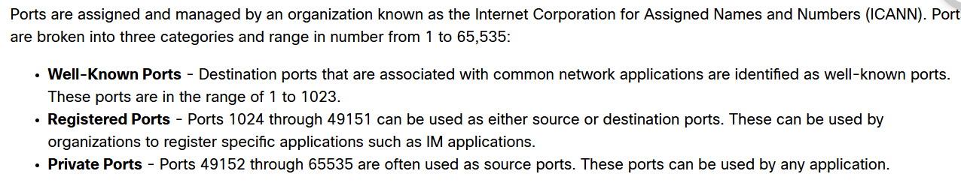

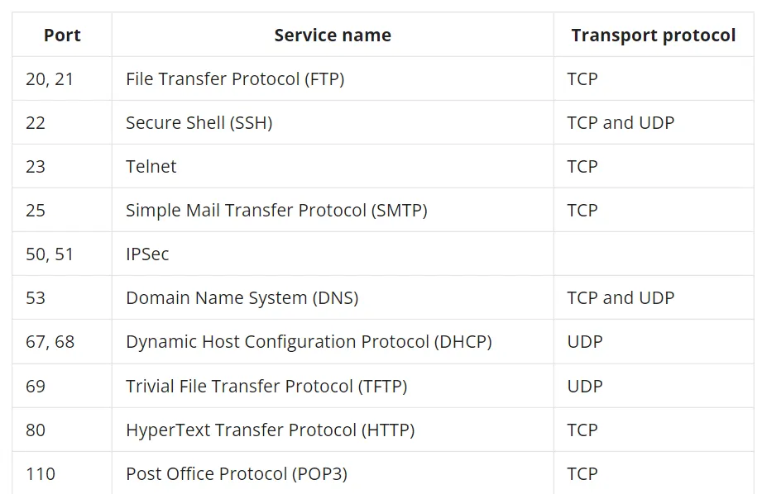

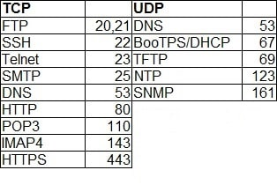

Socket Pairs
The source and destination ports are placed within the segment. The segments are then encapsulated within an IP packet. The IP packet contains the IP address of the source and destination. The combination of the source IP address and source port number, or the destination IP address and destination port number is known as a socket.
URI, URN, and URL
Web resources and web services such as RESTful APIs are identified using a Uniform Resource Identifier (URI). A URI is a string of characters that identifies a specific network resource. As shown in the figure, a URI has two specializations:
- Uniform Resource Name (URN) - This identifies only the namespace of the resource (web page, document, image, etc.) without reference to the protocol.
- Uniform Resource Locator (URL) - This defines the network location of a specific resource on the network. HTTP or HTTPS URLs are typically used with web browsers. Other protocols such as FTP, SFTP, SSH, and others can be used as a URL. A URL using SFTP might look like: sftp://sftp.example.com.
These are the parts of a URI, as shown in the figure:
- Protocol/scheme - HTTPS or other protocols such as FTP, SFTP, mailto, and NNTP
- Hostname - w​ww.example.com
- Path and file name - /author/book.html
- Fragment - #page155
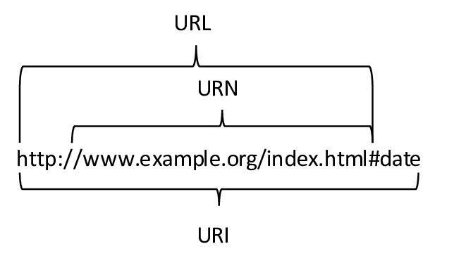
File Transfer Protocol
In addition to web services, another common service used across the internet is one that allows users to transfer files.
The File Transfer Protocol (FTP) provides an easy method to transfer files from one computer to another. A host running FTP client software can access an FTP server to perform various file management functions including file uploads and downloads.
The FTP server enables a client to exchange files between devices. It also enables clients to manage files remotely by sending file management commands such as delete or rename. To accomplish this, the FTP service uses two different ports to communicate between client and server.
Email Protocols
Simple Mail Transfer Protocol (SMTP)
SMTP is used by an email client to send messages to its local email server. The local server then decides if the message is destined for a local mailbox or if the message is addressed to a mailbox on another server.
If the server has to send the message to a different server, SMTP is used between those two servers as well. SMTP requests are sent to port 25.
Post Office Protocol (POP3)
A server that supports POP clients receives and stores messages addressed to its users. When the client connects to the email server, the messages are downloaded to the client. By default, messages are not kept on the server after they have been accessed by the client. Clients contact POP3 servers on port 110.
Internet Message Access Protocol (IMAP4)
A server that supports IMAP clients also receives and stores messages addressed to its users. However, unlike POP, IMAP keeps the messages in the mailboxes on the server, unless they are deleted by the user. The most current version of IMAP is IMAP4 which listens for client requests on port 143.
Many different email servers exist for the various network operating system platforms.

